50x50 Recovering the Classics
Design-a-Thon Exhibition and Event
December 4, 5:30 East Library

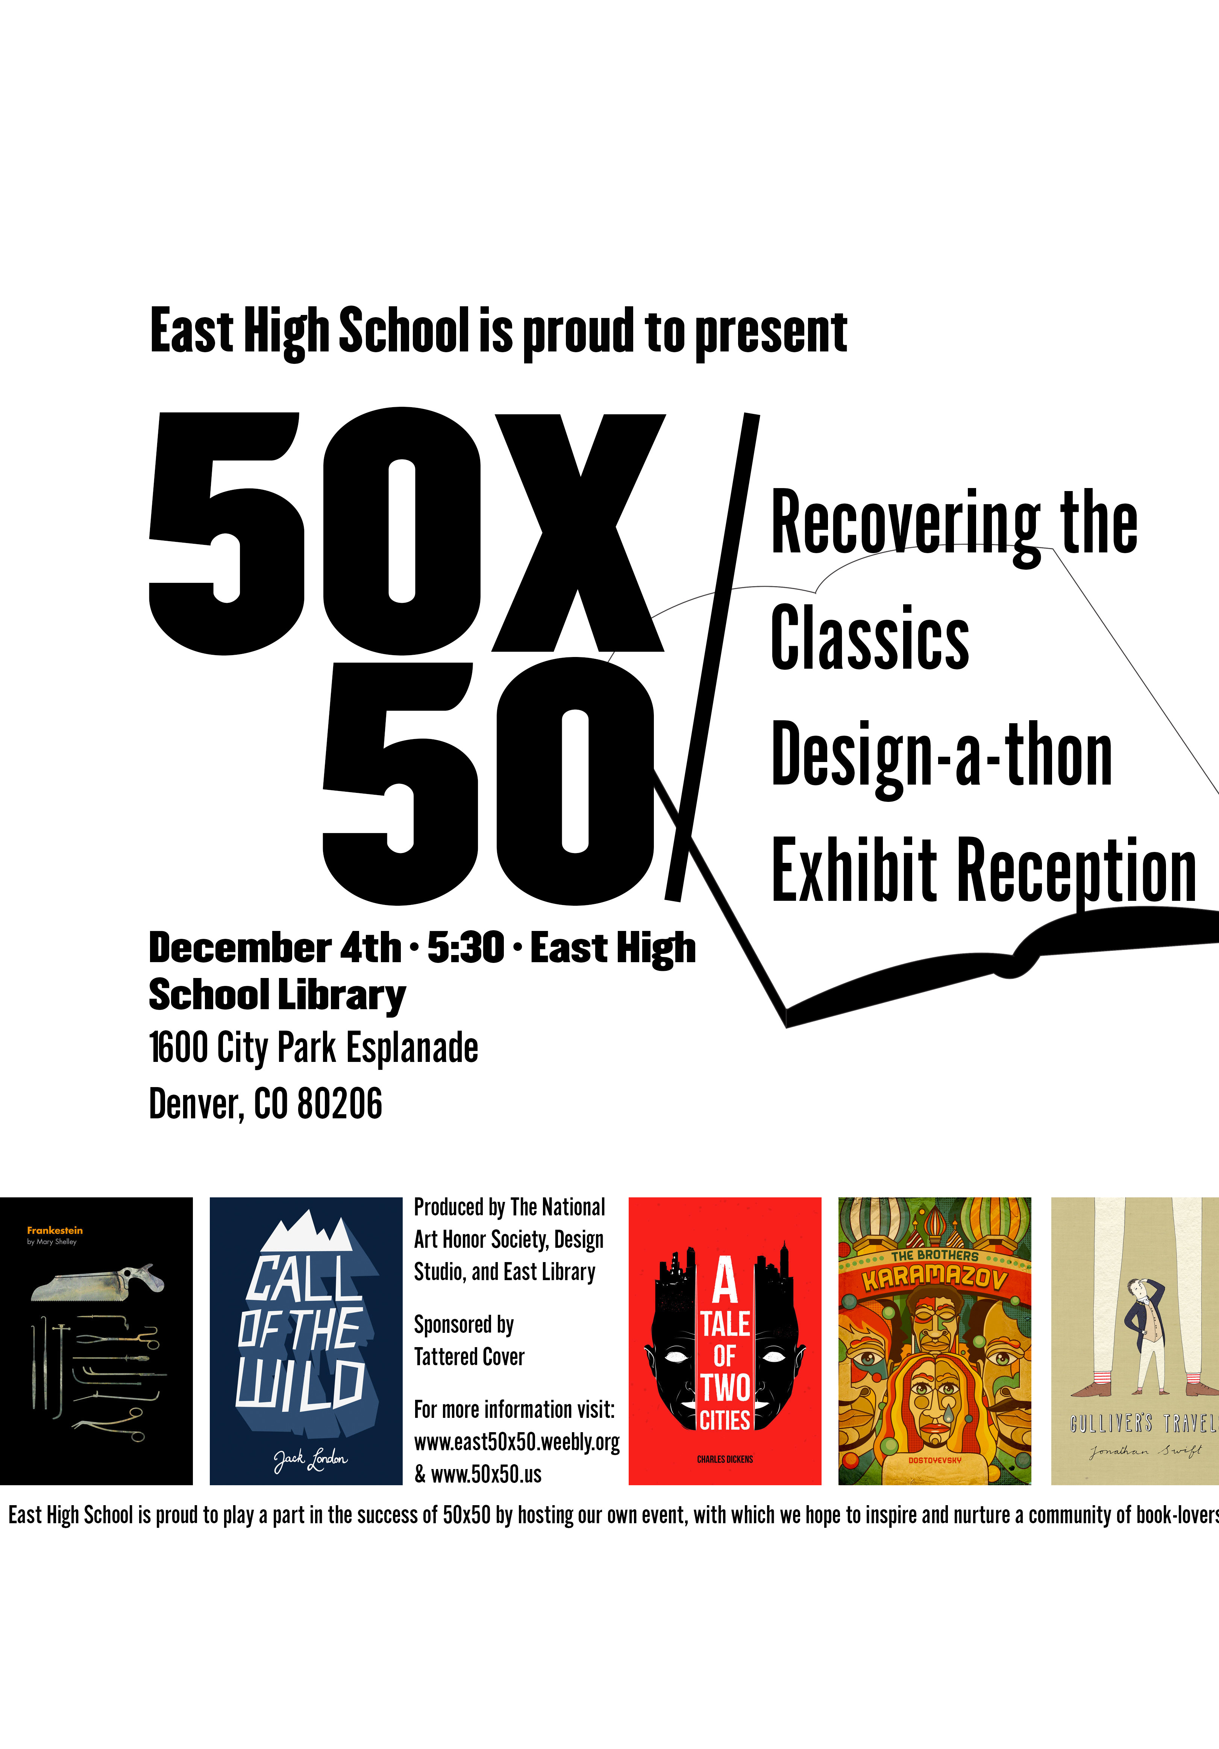
East High School is proud of its participation as a Colorado host of 50 x 50: Recovering the Classics Design-a-Thon event and exhibition.

Recovering the Classics national organizers are attempting to organize 50 of these events in 50 states by the summer of 2016. The exhibit and reception of redesigned classic book covers, produced by East High School students and guest artists, will be held on Friday, Dec. 4, at 5:30 p.m. in the historic East High School Library (1600 City Park Esplanade) in Denver.

All East High School students, including art and design students, were invited to participate. Student organizations, members of the National Art Honor Society and Design Studio helped organize and promote the 50 x 50 event.

With this exhibition, the school hopes to ignite a renewed interest in classic books. The exhibition will include redesigned covers from East students, staff and guest artists as well as crowd-sourced versions from artists and designers around the world.

Background of 50x50 Event
In 2013, Recovering the Classics asked designers/artists from around the world to re-imagine covers for great books in the public domain. Last spring, a partnership with the New York Public Library, the White House and the Digital Public Library of America was announced to bring the covers to libraries and schools nationwide through special edition ebooks. They are now looking for libraries, schools, book stores, galleries, local civic organizations, and others across the country to create their own events around the covers—exhibits, readings, school activities, or design-a-thons.

East High School is proud to play a part in the effort to have 50 classic book covers exhibited in all 50 states and to help nurture communities of book-lovers in the process.

Presented by East’s National Art Honor Society and East Library
Sponsored by Tattered Cover Book Store

